Cashmore Early Years Centre Newsletter
March 2019

Telephone: 0117 3534295 Facebook: Cashmore early years centre
Website: www.cashmoreearlyyearscentre.co.uk Email: cashmore@bristol-schools.uk
Website: www.cashmoreearlyyearscentre.co.uk Email: cashmore@bristol-schools.uk

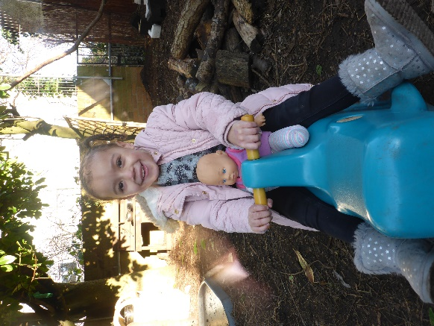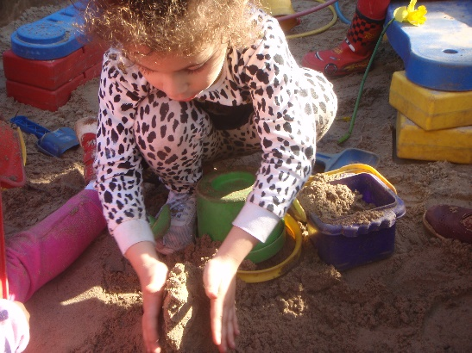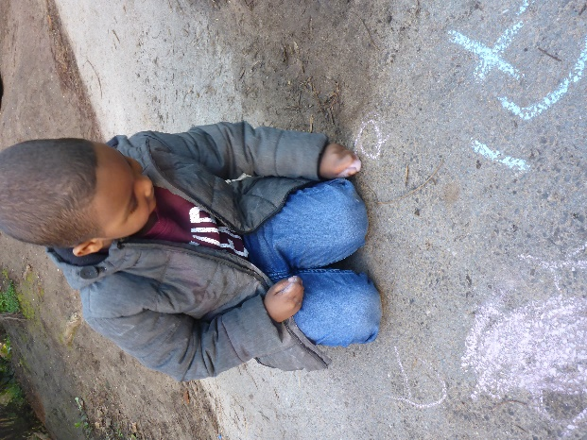
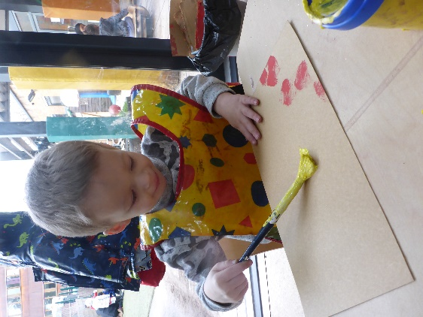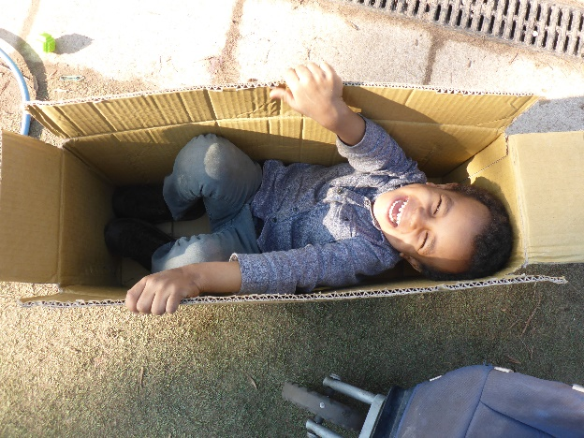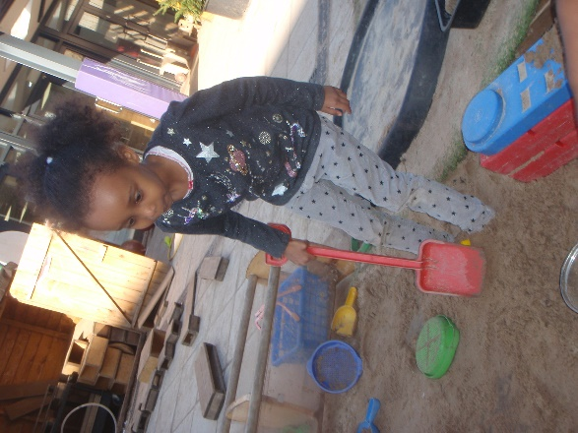

Important Dates
School Photographer – Wednesday 3 April
Easter holidays - School CLOSED – Monday 8 – Monday 22 April (inclusive)
Return to School – Tuesday 23 April
Monday 6 May – School CLOSED for Bank Holiday
Wednesday 12 June – INSET Day – School CLOSED

Appropriate clothing

We go into the garden in all weathers and children will need appropriate clothing and footwear. Please ensure that your child always brings a waterproof coat and footwear (e.g. wellies). The weather is changeable and even if it is sunny when you arrive at school, it may rain later during your child’s session.

Snack donations
The school provides milk but we rely on donations from parents for snack times during the morning and afternoon sessions. The children eat fresh fruit (e.g. apples, bananas, oranges, pears) or vegetables (e.g. carrots, cucumbers). Your child’s key person will put a slip in your child’s bag the week prior to it being their group’s turn to donate. Please check your child’s bag. Your donations are greatly appreciated.
Desperately seeking…
Dear Parents/Carers
We would be very grateful for donations of the following items:
- Small nets
- Whisks
- Old telephones/cameras
- Children’s prams/pushchairs
- Play kitchens (in good condition)
- Items for treasure baskets
  - Wooden curtain rings
  - Small wooden brushes (e.g. scrubbing brush)
  - Wooden/metal bowls
  - Wooden spoons
  - Metal kitchen utensils
- Items for mud kitchen
  - Pine cones
  - Conkers
  - Small garden stones
  - Larger pebbles
- Plant pots for garden decoration
- Large floor cushions/bean bags
- Plastic mini beasts
- Easter craft items
- Spare clothes for changing children
  - Trousers
  - Socks
  - Wellies
Thanking you in anticipation.

