Morning Routine
 | 9.00 | Welcome Time  & Key Group Investigation
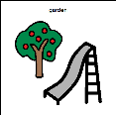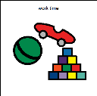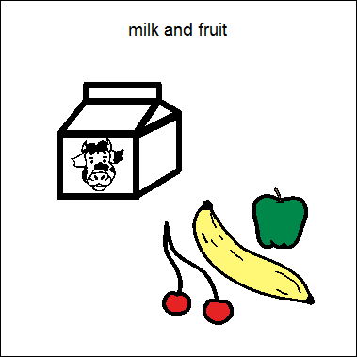  work time | 9.15-20 | Work Time & Snack Bar (9.45-11.00)  (Nappies 10.15-11.15)
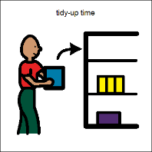 | 11.15 | Sort and tidy  11.10 Five minute notice  11.30 Doors open
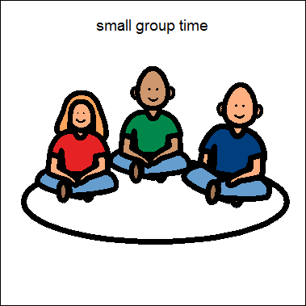 | 11.35 | Key Group Time
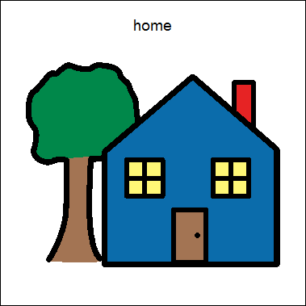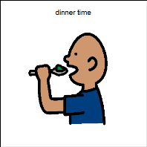 | 11.50-12.00 | Goodbye Time / Lunch Time

Afternoon Routine
 | 12.30 | Welcome Time  & Key Group Investigation
work time | 12.45-50 | Work Time & Snack Bar (1.15-2.30)  (Nappies 1.45-2.45)
 | 2.45 | Sort and tidy  2.40 Five minute notice  3.00 Doors open
 | 3.05 | Key Group Time
 | 3.20-3.30 | Goodbye Time

